

Medellín, April 2023

Version 1

**CONFIDENTIAL USE**

**API CERTIFICATION GUIDE**

**Cs-**

Instructions for use

Document Statement

This document was prepared by, for and shall remain the property of *Evertec®*  
for your confidential use.

The client agrees by his acceptance or use of these documents, to return them at the request of *Evertec®* and not to reproduce, copy, lend or otherwise disclose or dispose of their contents, directly or indirectly and not to use them for any purpose other than that for which they were specifically prepared.

**TABLE OF CONTENTS**

1. TRADE ACTIVITY 4

2. PAYMENT PROCESS 4

3. CORPORATE IMAGE 5

4. FREQUENTLY ASKED QUESTIONS 5

5. TERMS, CONDITIONS AND PRIVACY POLICIES 5

6. USE OF TAXES 6

7. SECURITY REQUIREMENTS 6

8. CHECKOUT BUTTON AND RETURN 7

9. TYPES OF CREDIT AND INTEREST CALCULATION (Ecuador only) 7

10. GENERATION AND VALIDATION OF OTP (Ecuador only) 8

11. 3DS GENERATION & VALIDATION 8

12. PINPAD-PINBLOCK GENERATION AND VALIDATION (Puerto Rico only) 9

13. IDEMPOTENCE CONTROL 10

14. SENDING KOUNTS (In case of enabling the service) 11

15. VALIDATION FIELDS(PROCESSTRANSACTION) 11

16. RESPONSE HANDLING FOR TRANSACTIONAL STATES 14

17. PROOF OF SALE 17

18. TRANSACTIONAL HISTORY 18

19. INFORMATION SECURITY 18

20. INFORMATION PROCESSING 19

21. CONSISTENCY OF INFORMATION 19

22. REVERSE TRANSACTIONS 20

23. RELEVANT INFORMATION 20

23.1. FORMAT OF RESPONSE TEMPLATES 20

23.2. TEST CARDS AND BANKS FOR TRANSACTIONS: 24

23.3. FINAL CONSIDERATIONS 24

Note: Use of this document is permitted for client installation purposes only.

Once the integration with Evertec Placetopay is done, it is necessary to carry out tests from the point of view of the end user to evaluate that the payment process is correct; therefore, the links and test data must be free of programming errors.

Below are the different aspects to take into account in the API certification process with the payment gateway.

For API certification, the following points are evaluated:

# TRADE ACTIVITY

The site must only process products and / or services related to the commercial activities established at the beginning of the negotiation, in case of being products not allowed by Evertec Placetopay the site will not be certified.

# PAYMENT PROCESS

The system must allow the buyer user to view the total amount to be paid before making the payment to the payment gateway, this value must match the value sent to Evertec Placetopay.

The merchant will define the process to make the breakdown of the product or service where the values and tax to be charged to the cardholder are evaluated. It can be through form, shopping cart, virtual store, invoice selection or others.

The system must avoid additional consumption when updating the status of a transaction when there is already a final state in the response of the **process**, so whenever there is a final state a new consumption should not be made to the **query** to know the status of the payment except for the PENDING status, according to the above at the time that a payment summary is provided and the transaction is updated in the trade system must be done in a general way in BD maintaining traceability and avoiding additional consumption according to the state given by Evertec Placetopay.

# CORPORATE IMAGE

The Evertec Place topay logo must be on the home page and in a size that makes it easily visible, it must be included through its urls with svg extension.

* **<https://static.placetopay.com/placetopay-logo.svg>**
* **https://static.placetopay.com/placetopay-logo-black.svg**
* **<https://static.placetopay.com/placetopay-logo-square.svg>**
* **[https://static.placetopay.com/placetopay-logo-square-dark-background.svg](https://nam01.safelinks.protection.outlook.com/?url=https%3A%2F%2Fstatic.placetopay.com%2Fplacetopay-logo-square-dark-background.svg&data=02%7C01%7CCarlos.Moreno%40evertecinc.com%7Cc8b65787e57c4ef072b008d7becc51c1%7C2b5b7d77f19b4c6db1805768c09ad43b%7C0%7C0%7C637187657154455565&sdata=wbBCIxS%2B0gqHeaeBnFrsKb5Ju6LpWMXGF%2FF4iph%2F%2B0w%3D&reserved=0)**
* **https://dev.placetopay.com/web/wp-content/uploads/2020/08/LOGO-P2P-blanco-developers-1.png**

In addition to this, it must contain a hyperlink to our informative home page: **https://www.placetopay.com/web/**

It is also suggested to add the logos of the franchises available to make payments, so that the customer has knowledge of the means of payment enabled for commerce.

# FREQUENTLY ASKED QUESTIONS

Include within the Frequently Asked Questions (FAQ) section of the merchant application one or more points related to electronic payments and mention payments through Evertec Placetopay. In case the business does not have a FAQ section, the frequently asked questions provided in the documentation must also be included.

Note: The FAQ should not mention or refer to terms of online payments or online payments

# TERMS, CONDITIONS AND PRIVACY POLICIES

You must have a portal or link, either in the navigation menu, footer or a check before making the payment process, which establishes the causes of the user in the face of any question, complaint or claim and additional detail the way in which the information of the users who have interaction with the web will be processed, that is, how the information will be collected, how it will be stored, what it will be used for and whether it will be shared.

# USE OF TAXES

In the event that within the regulation of the country and business model it is mandatory to send taxes to banks, the trade must discriminate the VAT and ICE of the products in the transaction. The base, tax rate and tax value must be submitted.

This point will be validated in the visualization of the payment summary and in the request that is sent to Evertec Placetopay.

# SECURITY REQUIREMENTS

The configuration data of the Evertec Placetopay connection must be stored as parameters either in the database or in some .ini, .json, xml, etc. file. This should be done by good programming practices and so that when updating the key, the process is easier.

For sites that use JavaScript validations, the operation should be avoided when entering from a browser that has JavaScript execution disabled. It can be by avoiding page loading or by performing server-side validation.

It is recommended to implement encrypted password in AES256 to authenticate users to the merchant site.

For no reason should the merchant store or display sensitive data of the cardholders' cards. The data that are considered sensitive are:

* Credit card number.
* CVV (Verification Code).

# CHECKOUT BUTTON AND RETURN

The merchant must parameterize a control that prevents the user and application from making double requests to the Evertec Placetopay service, either because the service takes time to respond at the time the payment response is given or by user interaction with the button.

Keep in mind that once the payment is made, in case the user returns through the previous and next instructions of the browser, it is recommended that the order be loaded again, because the sending of the same order to the payment process should be avoided since this will incur a double payment depending on the times the user does it.

# TYPES OF CREDIT AND INTEREST CALCULATION (Ecuador only)

The merchant must make available to the user the types of credit allowed for their payment process, according to the initial consumption to consult and validate the information of the card **information**:

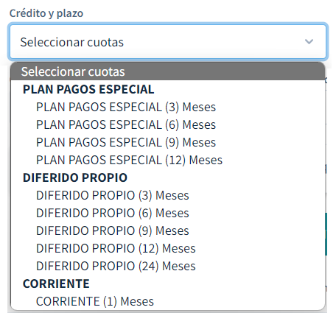

Once the user selects the type of credit to be used, the calculation of interest according to the type of credit selected by the interests method must be shown:

Graphical User Interface, Text, Application, Email

Automatically generated description

The type of credit selected by the user must be sent in the request at the time the process is to be made **.**

# GENERATION AND VALIDATION OF OTP (Ecuador only)

The merchant must generate, validate and make available to the user a field either in a modal or within the same interface, which must be as required and allow the entry of only numerical values, according to the initial consumption to consult and validate the information of the card information:



Once the user enters the otp and is validated against the service **validate** the response will provide a signature that must be sent in  **the processtransaction** as otp if the response has been satisfactory.

In case the validation of the otp is not done correctly, the detail of error that the api itself provides when performing the validation must be given and if the 3rd attempt is fulfilled which responds with blocking towards the operation, the operation must be blocked or completed from the trade.

In addition to this, please rely on the official documentation:[OTP generation (Ecuador only) | API Gateway (placetopay.com)](https://docs-gateway.placetopay.com/docs/api-services-docs/af61d9facbe17-generacion-de-otp-solo-ecuador)

# 3DS GENERATION & VALIDATION

The merchant must raise a 3DS authentication flow for the user either in a modal or through redirection, according to the initial consumption to consult and validate the information of the card **information**:

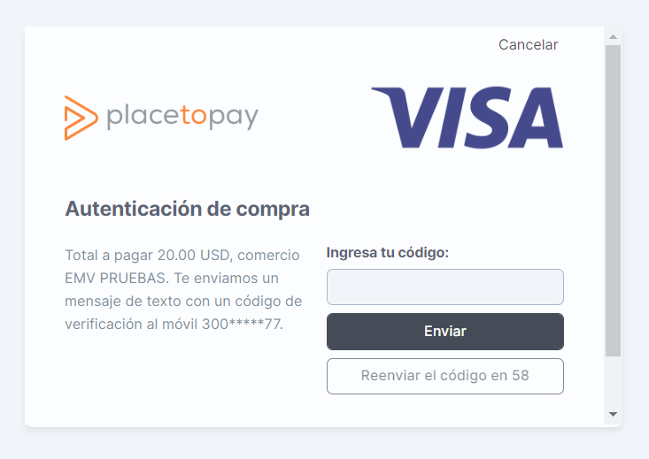

Once the user returns from the validation, the authentication information must be consulted through the **query,** and the response will provide all the detail that must be sent in the **processtransaction** as **threeDS.**

In addition to this, please rely on the official documentation: [3DS Lookup | API Gateway (placetopay.com)](https://docs-gateway.placetopay.com/docs/api-services-docs/069b36e2cf444-3-ds-lookup)

# PINPAD-PINBLOCK GENERATION AND VALIDATION (Puerto Rico only)

The merchant must generate, request and make available to the user a PINPAD either in a modal or within the same interface, which must be as required and allow the entry of only numerical values, according to the initial consumption to consult and validate the information of the card **information**:

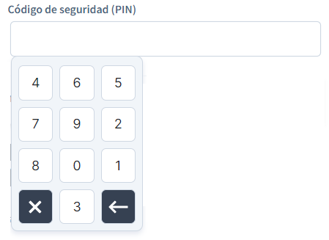

Once the user enters the pin, the pinblock is generated from the positions given by the user through the pinblock method the  **response will provide the pinblock that must be sent in the** processtransaction **as a pin.**

In addition to this, please rely on the official documentation: [PinPad Application | API Gateway (placetopay.com)](https://docs-gateway.placetopay.com/docs/api-services-docs/5b2b8c3a230f8-solicitud-de-pin-pad)

# IDEMPOTENCE CONTROL

To control that you do not perform more than one approved transaction for a single process in a predetermined time period. This is done by identifying that process with a unique value that would be sent in the idempotenceKey parameter.

{

...

"idempotenceKey": "ABCD1234",

"instrument": {

...

}

For more details please refer to the official documentation: <https://docs-gateway.placetopay.com/docs/api-services-docs/b61e09e4d5989-control-de-idempotencia>

# SENDING KOUNTS (In case of enabling the service)

The system must send in the messaging processtransaction  **a** kount object with the attributes of a session which is a unique random value for each transaction and a default type:

"kount": {

"session": "CO485",

"type": "default"

}

In addition to this, please rely on the official documentation:[Transaction Processing | API Gateway (placetopay.com)](https://docs-gateway.placetopay.com/docs/api-services-docs/b736ea6925314-procesamiento-de-transaccion)

# VALIDATION FIELDS(PROCESSTRANSACTION)

The merchant must at least submit the following required fields in the payment request:

Buyer and payer data:

* Type of buyer-payer document. (Optional in Puerto Rico)
* Buyer-payer document number. (Optional in Puerto Rico)
* Name of buyer-payer.
* Last name of the buyer-payer.
* Buyer-payer email.
* Buyer-payer's cell phone.

Payment details:

* Reference
* Description (optional)
* Coin
* Value.
* VAT (optional)
* Return base (optional)
* Dispersion (In case of enabling the service)
* Covenant
* Type of agreement
* Coin
* Total
* Recurrence (In case of enabling the service)
* Periodicity
* Interval
* Next payment date
* Maximum number of periods
* Date to end recurrence
* Url for payment confirmation (optional)

Card data (instrument)

* Card
  + Number or PAN
  + Expiration
  + CVV
  + Quota
* Credit (Ecuador only)
  + Code
  + Guy
  + Group Code
  + Deferred
* OTP (Ecuador only)
* threeDS
* Id
* Wrapped
* Authenticated
* Valid signature
* Eci
* Cavv
* Xid
* Version
* Extra
  + Reason authentication status
  + AcstransId
  + threeDSServerTransID
* Pinpad (Puerto Rico only)
  + TransactionId
  + Positions
  + PinBlock
  + Longitude
* Pin (Puerto Rico only)
* Kount (In case of enabling the service)
  + Session
  + Guy

Additional data

* IP.
* Navigation agent.

Important: You should be aware that each of the fields must contain consistent information. In addition to this, please rely on official documentation in case of changes: [Transaction Processing | API Gateway (placetopay.com)](https://docs-gateway.placetopay.com/docs/api-services-docs/b736ea6925314-procesamiento-de-transaccion)

* The system asks the user for the card number as a mandatory field, it only receives numerical values. and has a length of 13 to 19 characters, validating the value typed through Luhn's algorithm.
* The application requests or presents to the user the expiration date as a mandatory field, validating that the expiration date is not expired and only receives the value of the month from January to December, that is, from 01 to 12 (Always in two digits). Allowing a maximum election of 10 years, from the current date.
* The system asks the user for the CVV2 as a mandatory masked field, only receives numerical values and has a maximum length of 4 characters (American Express is the only one that must allow a maximum of 4 characters, Visa, Mastercard, Discover and Diners only 3).
* The reference must contain a maximum length of 32 alphanumeric characters and must not contain or store the card number and special characters being unique for each request.
* For the data of the buyer and payer (buyer-payer) must validate each of the fields that are being sent to Evertec Placetopay as required at the time the user is entering the information.
* For the validation of the document, the restrictions in the field must be implemented, according to the type of document selected by the user, the validations of the documentation can be taken as a reference: [Document types | API Gateway (placetopay.com)](https://docs-gateway.placetopay.com/docs/api-services-docs/ZG9jOjExNjAxOTcz-tipos-de-documento)
* In case the identity document belongs to a natural person, for the name and surname fields the entry of numbers or special characters should not be allowed, however, it must allow the entry of the tilde, spaces and the letter Ñ. Otherwise, that is, companies must be sent only under name, the company name or trade name and for this case if numbers should be allowed.
* For numeric fields such as mobile or telephone should not allow the entry of letters, or special characters.
* For the email field it must have a valid structure, [user/to]@[domain]. [Source type]. [Extension].
* The IP address and navigation agent must be that of the end user's computer.

In the payment process the buyer is not always the same owner, so this information must be taken into account when sending this data to Evertec Placetopay.

Note: The implementation of asking for card ownership is considered a good practice and is optional, however, if the merchant makes the determination not to implement this, they must ensure that they always send the payer or cardholder information.

# RESPONSE HANDLING FOR TRANSACTIONAL STATES

At the time the user completes his payment process, the detail of the transaction must be displayed, at least the following data must be displayed:

* Reference.
* Final transaction status
* Approved
* Rejected
* Earring
* Unsuccessful
* Approved Partial (only in dispersion)
* Reason and message
* Date and time.
* Total value.
* Interests (Ecuador only)
* Type of credit (Ecuador only)
* Quotas
* Currency with which the payment was made.
* Receipt.
* Authorization.
* Bench.
* Last 4 digits of the card

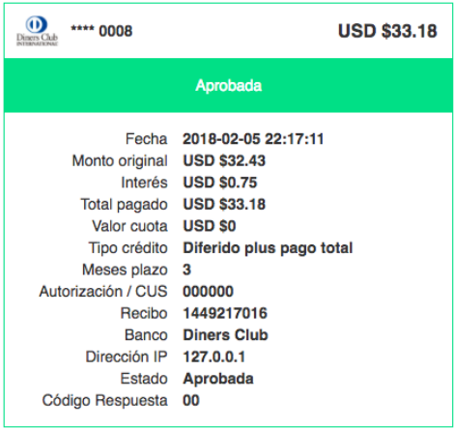

If you want to indicate more information to the end user, you can follow the format of RESPONSE TEMPLATE FORMAT described in this document, showing the status according to the response issued by Evertec Placetopay.

Recommendations aligned to the user experience:

* Approved response: it is possible to add a link or button that allows the user and / or client to go to the beginning (home) of the payment process, in the same way the reception will be evaluated.

Image containing Logo

Automatically generated description

* Rejected and failed response: it is recommended to add a link or button that allows the user and / or client to retry the payment.

Text

Auto-generated description with low confidence

**Important:** In the case of dispersion it will be validated that no error occurs under a transaction that has been rejected by Scudo, in this way from the trade you must have control with the interaction of the payment type arrangement [ ] under the casuistry of the dispersion arrangement [ ], taking into account that according to the risk configurations in a transaction the result of the dispersion arrangement can be altered[ ], which if not properly controlled can generate an error in the trade.

**Pending transaction control:** You can view a transaction in pending status by direct response from the financial institution or non-receipt of response by Evertec Placetopay (TimeOut).

There are three ways to obtain the final status of a transaction, the first with the response of the service at the time of making the processtransaction and the other 2 in case of **receiving a PENDING status through**  the query method  **having the internal reference and the last**  with the search service  **which is a contingency in case of loss of communication when creating the transaction with the** processtransaction**.**

Note: The consumption towards the service to know the final status of a pending transaction must always be done through the **query** method, the use of the **search** method is only in case of loss in communication when the transaction is made.

When consuming the **processtransaction service**  timeout is generated in the connection to Evertec Placetopay (it must be around 25 seconds) and no response is obtained from the service, the operation must be marked in pending state and search for the transaction through the **search** method, meanwhile this transaction must comply with the general behavior of this state (double payment control and probe process)

* **Probe or Cronjob:** This process consists of a scheduled task (cronjob) which is responsible for consuming the  **query method (transaction query) on transactions that were in pending status in their records, this procedure must be executed every 15 minutes verifying transactions that have more than 7 minutes in pending state.**

When a pending transaction is found in the database, the system should report and present the following event:

* A **double payment control message** informing the user of the existence of pending transactions, before making a new payment. For example:
* "At this time your order with *#Referencia* and value of *#Amount* is in a PENDING state of not receiving confirmation from your financial institution, please wait a few minutes and check back later to verify if your payment was confirmed successfully. If you want more information about the current status of your operation you can contact our customer service lines *000-00-00* or send an email to email@email.com and ask for the status of the transaction: <#CUS/Authorization>***".

When a transaction is found in a partial approval state (dispersion only) in the database, the system should report and present the following event:

* An **informative message** to the user indicating the existence of partial approved transactions and the control or handling, in accordance with the business policy that will be provided on this transaction, before making a new payment.

**Important:** For dispersion, the operational and functional process must be defined to give control to transactions under PARTIAL APPROVED status, in such a way that an internal control in the trade is defined for this type of situations on transactions.

# PROOF OF SALE

In the event that the system sends proof of sale (printing, e-mail, exported file, voice message) according to each of the transaction statuses and information related to the payment is presented, it is validated that the information shown is contrasted with the transaction information verifying that according to the fields shown the information is consistent in relation to the payment. It is recommended that the user view the following information:

* The reference.
* Date and time of the transaction.
* The status of the transaction.
* Total paid by the user.
* Type of credit and deferred (Ecuador) or fee selected by the end user.
* The last four digits of the card
* Bench

If you do not have your own proof of payment, the voucher issued by Placetopay Evertec is taken as a reference.

# TRANSACTIONAL HISTORY

In case it is necessary to authenticate on the merchant's site to carry out a payment process, it must be allowed to consult the status of at least the last ten (10) transactions made. Each record must contain at least the following data sorted in descending order by date:

* Date and time of the transaction.
* Reference number (issued by the merchant).
* Authorization/CUS. (optional)
* The status of the transaction.
* Value (must be concatenated with the currency type according to ISO 4217).

Board

Automatically generated description

Note: In case you do not use login on the page and by business rules it is not possible to implement a section where payments can be consulted, you must inform the analyst of Evertec Placetopay, the reason or reason for it to be analyzed and give the exception on this.

# INFORMATION SECURITY

The system and trade must meet the following criteria:

* The trade must be PCI certified (current)
* The system under no circumstances stores sensitive information of the cardholder.
* The system does not show in the payment summaries, sales receipts or any other section facing the user the card number (maximum BIN and last 4 digits)
* The system does not show in the payment summaries, sales receipts or any other section facing the user the CVV of the card.
* The minimum information for a future claim is stored in the application database (date and time of transaction, receipt number, transaction value, authorization number, maximum 4 last digits of the card number, reference and promissory note, the latter if applicable).
* The system must have a valid digital certificate, capturing information using the secure HTTPS protocol.
* TLS protocol 1.2 or higher must be used.
* If the development uses a web interface (even intranet) the information capture URL is not masked (hidden) by techniques such as IFRAMES.

# INFORMATION PROCESSING

When making a transaction, the same data that was validated, typed or selected in the user interface is sent to the Evertec Placetopay application:

* Card number
* CVV
* Expiration Date
* Fee or Type of credit (Ecuador only)
* Total Value
* VAT
* Return Base
* User Information
* Information on security protocols

# CONSISTENCY OF INFORMATION

The information sent to Evertec Placetopay must not have contrasts in each interface in which information regarding the payment is presented, according to this the following aspects must be met:

* The date and time of the transaction presents a consistent value between the merchant development database, the Evertec Place topay console query and the proof of sale generated by the development when transactions are made.
* The last four numbers of the card appear in a unique and coincident way between the database of the development of the trade and the query of the console of Evertec Placetopay.

# REVERSE TRANSACTIONS

The reverse process of transactions must be defined, in case the trade is going to make reverses through the api exposed by Placetopay Evertec, the analyst must be confirmed, in order for him to validate the functionality and guarantee the correct operation, on the other hand, if the administrative console is going to be used, he must be informed through the mail in the thread of the analyst in charge.

Note: Depending on the closing date in the network, the reverse will not be effective the same day when the scenario that is made after this time arrives and in its case an extemporaneous reverse must be processed with the financial institution

# RELEVANT INFORMATION

## FORMAT OF RESPONSE TEMPLATES

Response templates are informative formats for the end user regarding their payment, so it is important to display the relevant data in the templates; They must be free of spelling errors, character encoding errors and be consistent as described below:

* Date and time of transaction.
* Value or amount of the transaction: Please note that they must be presented in two-digit decimal format along with the currency type (USD 938.99)
* VAT: Value charged of VAT applied with currency rate (USD 25.93)
* Transaction status: Which are: Approved, Rejected, Pending, Partial Approved (only in dispersion) and Failed. (The system responds with the states in English, it must be translated into the language that predominates on the page).
* Reason and Reason: It is the error message or reason for decline issued by the financial institution.
* Interest (Ecuador only): Interest payable on the transaction.
* Credit type (Ecuador only): Description of the type of credit selected by the user.
* Installments: Number of installments to which payment was deferred.
* Franchise: Name of the brand of the card with which the transaction was made.
* Bank: It is the entity to which the card or the account of the transaction belongs
* Authorization/CUS: It is the unique tracking code or authorization # issued by the financial institution.
* Receipt: Consecutive generated by the network, issued by Evertec Placetopay.
* Reference: It is the payment reference generated by each merchant and must be unique for each transaction.
* Description: You must actually indicate the concept or description of the payment.
* IP address: The IP address of the computer where the end user is performing the transaction must be displayed.
* Name of the buyer or customer: name and surname of the buyer or customer.
* Consultation: Phone, Email, or link to the inquiry form, where the user can obtain additional information about their transaction.

Note: The merchant must define the form and order for displaying the data, but labels and data structure are mandatory. The following are application examples for the response page on the site:

* Example of the response template (Transaction approved):

Graphical User Interface, Application

Automatically generated description

* Example of the response template (Transaction declined):

Graphical User Interface, Application

Automatically generated description

* Example of the response template (Pending transaction):

Graphical User Interface, Application

Automatically generated description

* Example of the Response Template (Partial Approved Transaction):

Graphical User Interface, Application

Automatically generated description

* Example of the response template (Transaction failed):

Graphical User Interface, Application

Automatically generated description

## TEST CARDS AND BANKS FOR TRANSACTIONS:

Due to PCI standards we can not include credit cards and attached information in emails, however, through the following link you can view the cards to perform the relevant tests: **<https://docs-gateway.placetopay.com/docs/api-services-docs/ZG9jOjIxNjA0MDM3-tarjetas-de-pruebas>**

Note: For all franchises:

* Check code: 123
* Card expiration date: Select a current date
* Otp: 123456

## FINAL CONSIDERATIONS

This information delivered together with the evaluation of expertise that is carried out on the site is fundamental, since they are taken into account for the test checklists and if all the points are not OK, the trade will NOT be able to go into production.

For the certification process, the information must be sent to the assigned analyst of Placetopay Evertec with the following data:

* **Test URL:** The site enabled to perform review and certification
* **Username and password:** Access data for the deposit and simulation of the payment.

[](https://www.facebook.com/Evertecinc/)[](https://www.instagram.com/evertec.inc/?hl=es)[](https://www.linkedin.com/company/evertec/posts/?feedView=all)[](https://twitter.com/evertec_inc/)